- Yo __________ una quesadilla, por favor.
- ¿Y para beber? -Una _________ por favor.
- ¿________ __________ un churro? -Un dólar y cincuenta centavos.
- ¿Algo mas? -___________.
- ¿Qué tipo de carne?-_______________.
Escribe como se llaman las cosas en las fotos debajo.
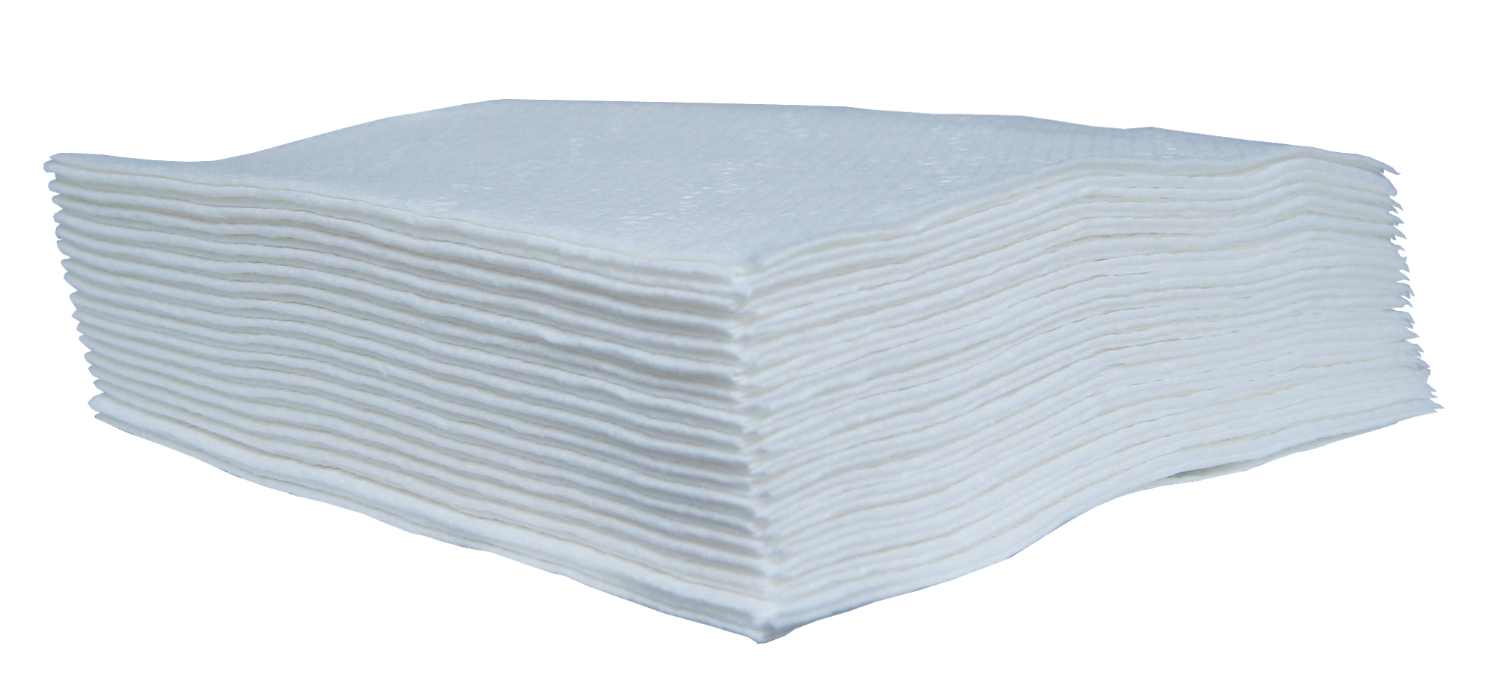 |  |  | 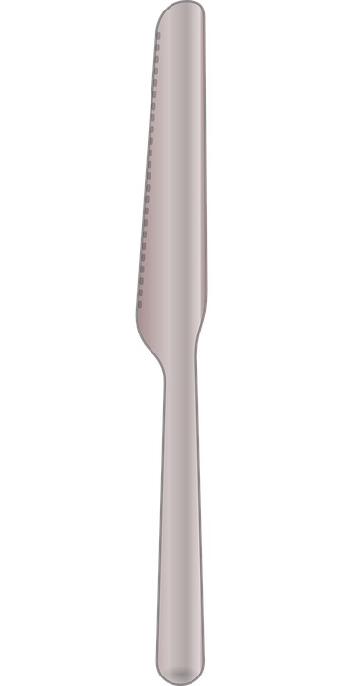 | 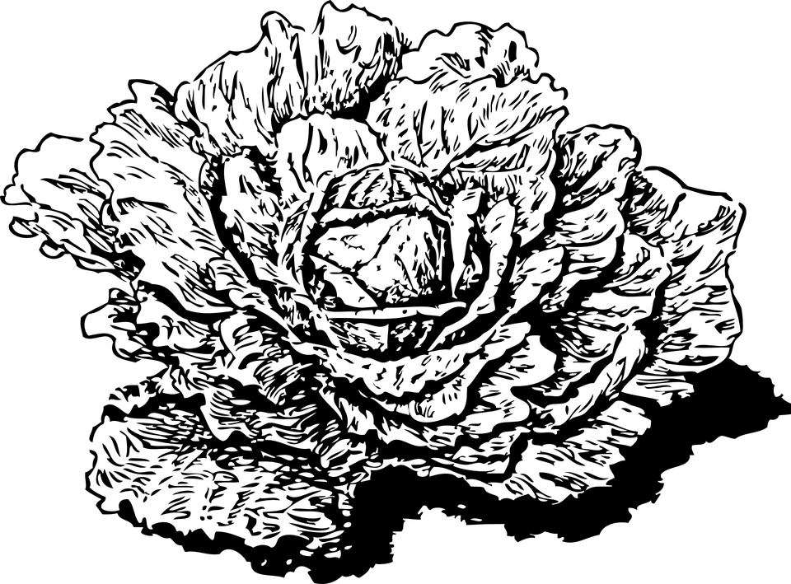
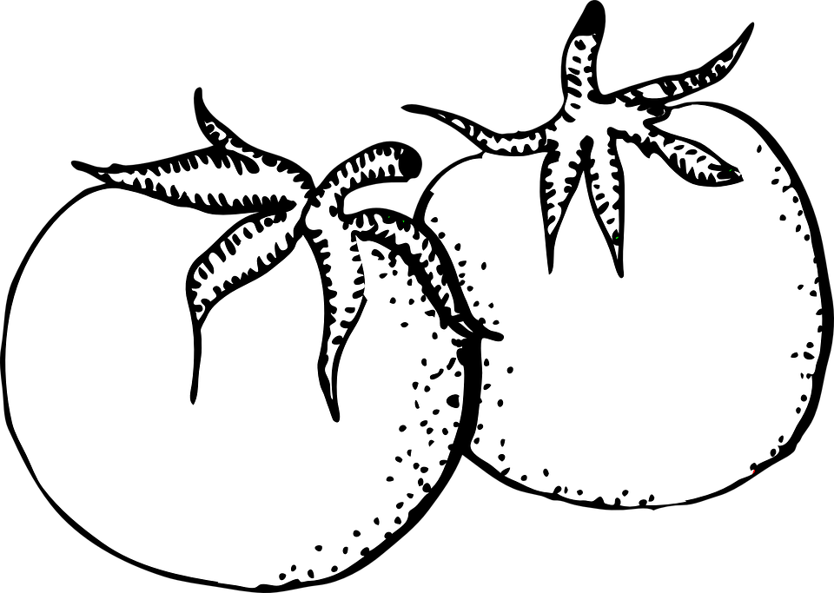 | 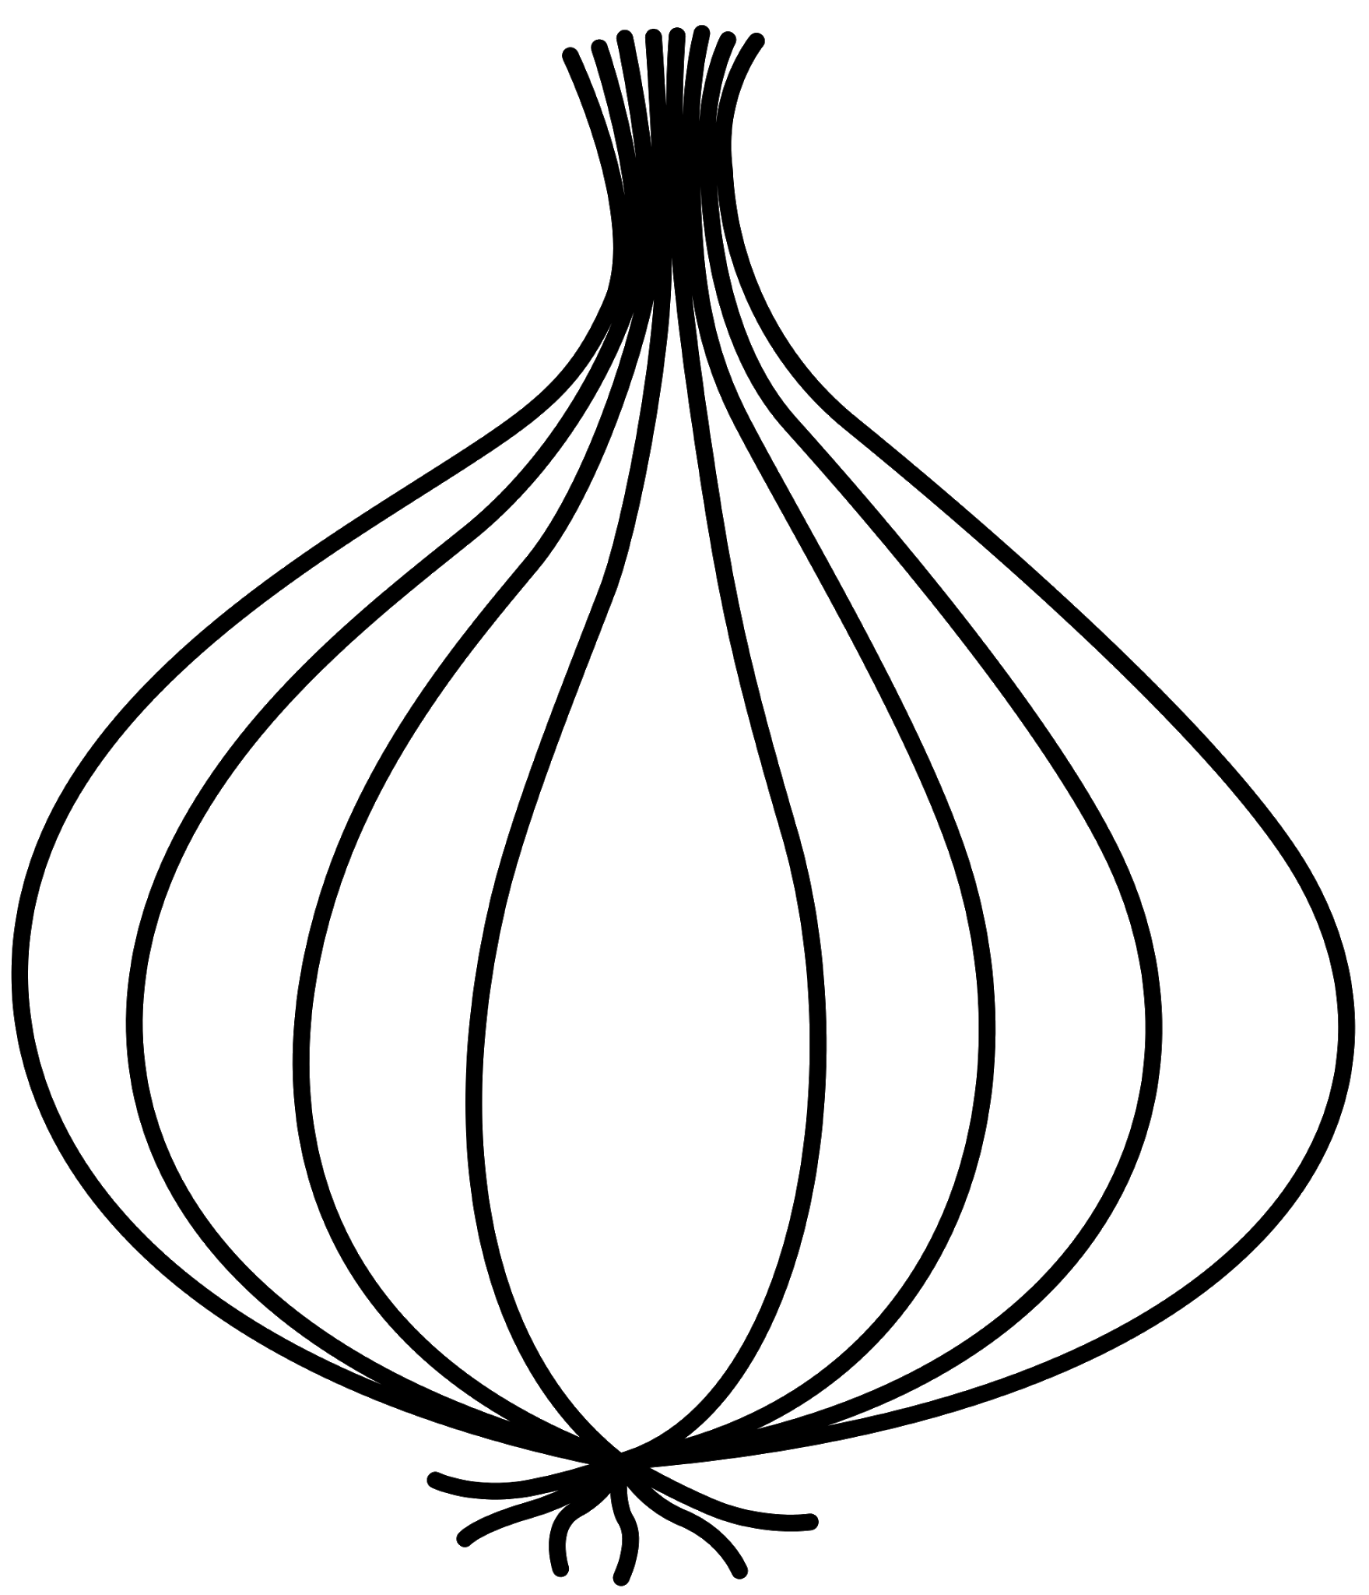 |  |  | 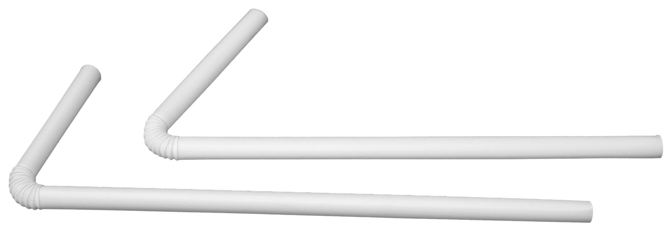
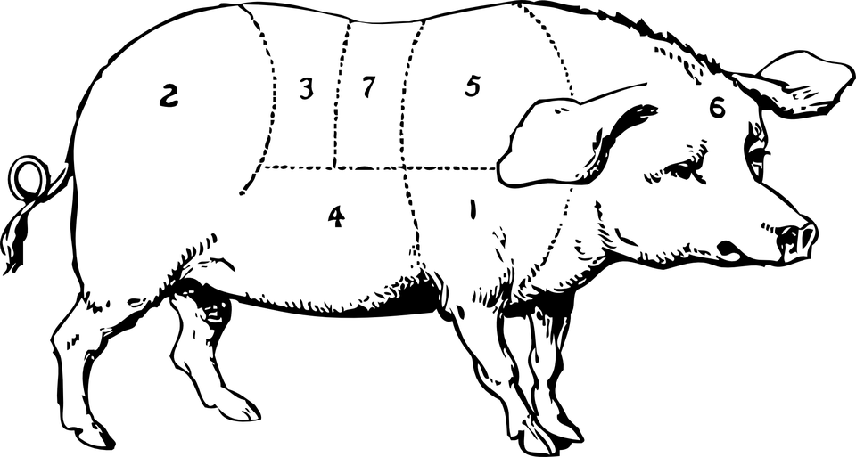 |  |  | 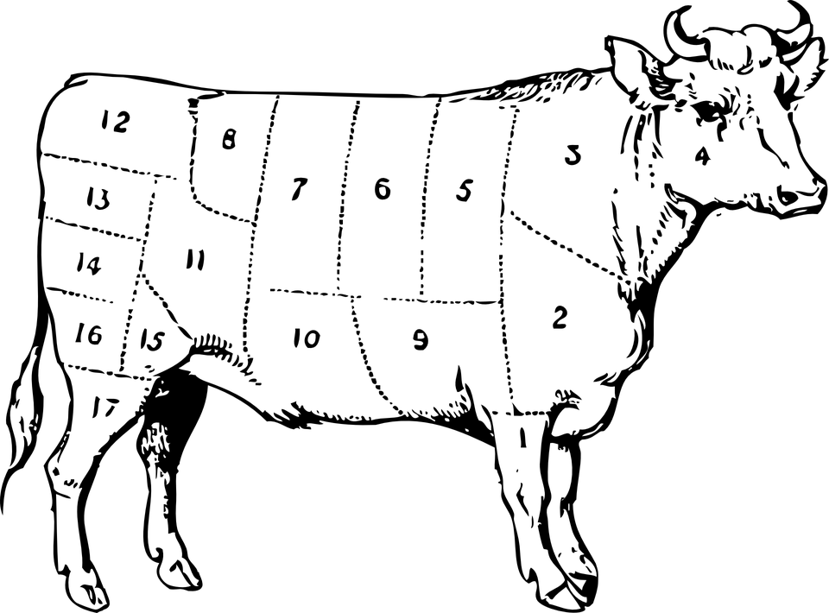 | 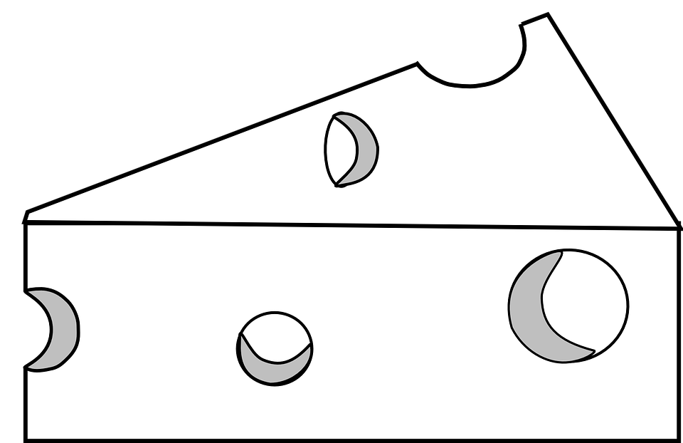
 | 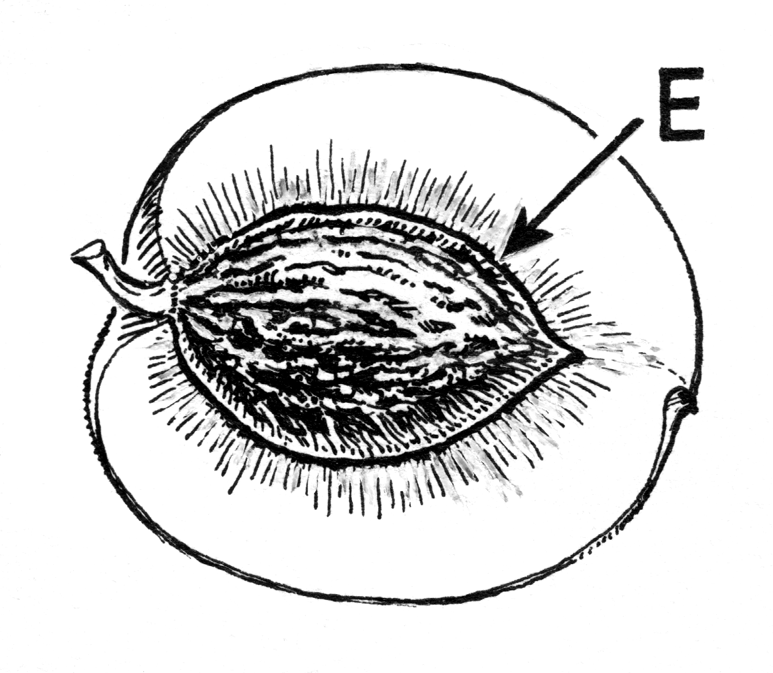
El gorro/sombrero el cerdo el aguacate la cuchara el queso
El helado la cebolla el tenedor la bolsa la camiseta
El durazno/melocotón la fresa el cuchillo la salchicha la lechuga
La servilleta el tomate el pollo la carne/el bistec el popote/la pajilla

FIELD TRIP REFLECTION
Rate your overall experience on the Spanish field trip (Just Okay to Excellent): 5 6 7 8 9 10

1. What did you enjoy the most? Why?

2. What you enjoy the least? Why?

Reading Activity with Kindergarten Children

3. How would you qualify your experience with your students? Was it a fun experience? Was it intimidating? Was it challenging? Explain.

4. Did you feel prepared to accomplish your task? Yes. No. Explain.

5. Would you like to do a similar activity in your future Spanish classes?

6. Suggestions for improvements.

Plaza Fiesta Experience
7. How difficult did you find the assignment at Plaza Fiesta?

8. How was your experience with the food?

9. Do you think you had sufficient/excessive time to do your activity?

10. Suggestions for improvements.

